BALDIVIS SECONDARY COLLEGE
 Methods Units 1 and 2
2020 Test 2

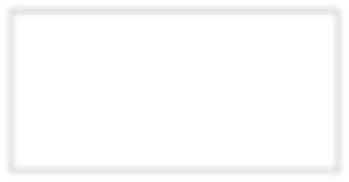
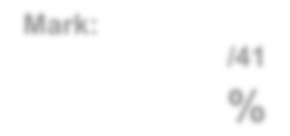

Mark:

/34

%

Student Name _____________________________________________

Time allowed for this task: 45 minutes, in-class, test conditions.
Section 1: 10 minutes + 2 minutes reading time
Section 2: 30 minutes + 3 minutes reading time

Materials required: Section 1 Calculator free section (9 marks)
Standard writing equipment
SCSA Formula Sheet

Section2 Calculator assumed section (25 marks)
Calculator (to be supplied by the student)
SCSA formula Sheet
One page A4 (double sided) unfolded

Other materials allowed: Drawing templates

Marks available: 34 marks

Task Weighting: 5%

Question 1 [2 marks]

Write 240⁰ as an angle in radians as a simplified fraction in terms of π

Question 2 [3 marks]

Express the following in radians:

a) 90⁰ b) 135⁰ c) 210⁰

Question 3 [2 marks]
A pendulum AB has end A fixed and a weight attached at B. In one swing, the pendulum travels from B to C and back again (see diagram).
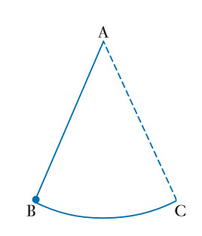
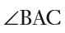
The pendulum is of length 80cm and = 0.9 radians.

How far does the pendulum travel in one swing?

Question 4 [2 marks]
Determine the equation of the linear function y = mx + c shown below. All values should be expressed in exact form.

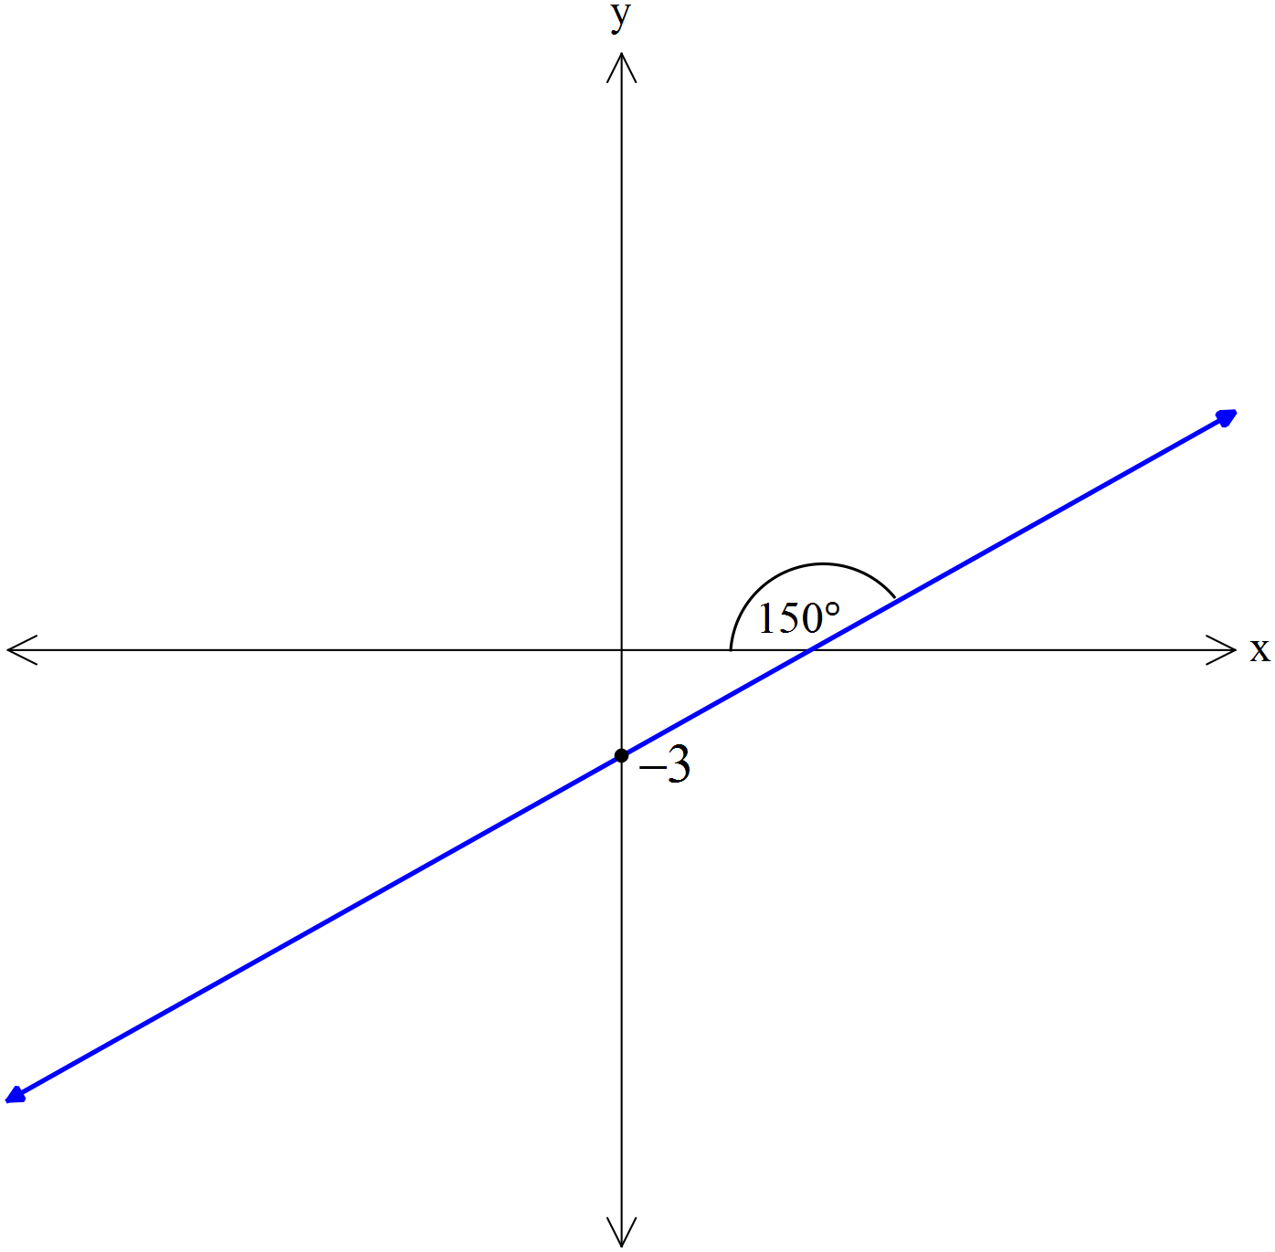



AEMAM Unit 1 – Test 2 – 2020

Name: Time allowed – 30 minutes

Calculator Assumed Section (1xA4 page of double sided notes, unfolded and approved
calculators. Formula sheet provided.) – 25 marks

Question 5 [8 marks – 4, 2, 2]

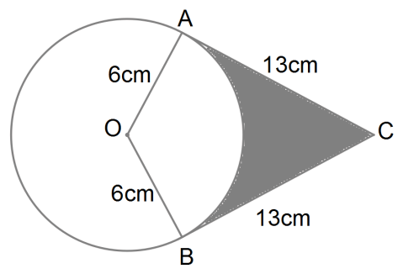
Two tangents drawn from point B to a circle
with centre O and radius 6cm touch the circle
at the points A and C.

a) Find the size of angle AOC correct to 4 significant figures.

b) Find the perimeter of the shaded region.

c) Find the area of the shaded region.

Question 6 [4 marks]

The diagram shows a sector BAC of a circle with centre A and radius 16cm. Angle BAC is 0.8 radians. The length AD is 7cm. Calculate the area of region BDC

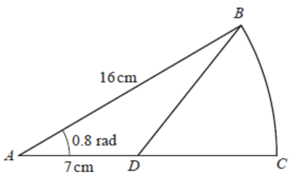

Question 7 [5 marks]

Determine the length of the minor arc GH.
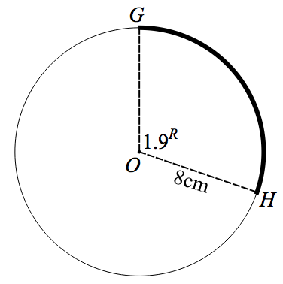

(b) Determine the size of the angle in the major sector in degrees.

(c) Determine the area of the minor segment GH.

Question 8 [8 marks – 2, 2, 2, 2]

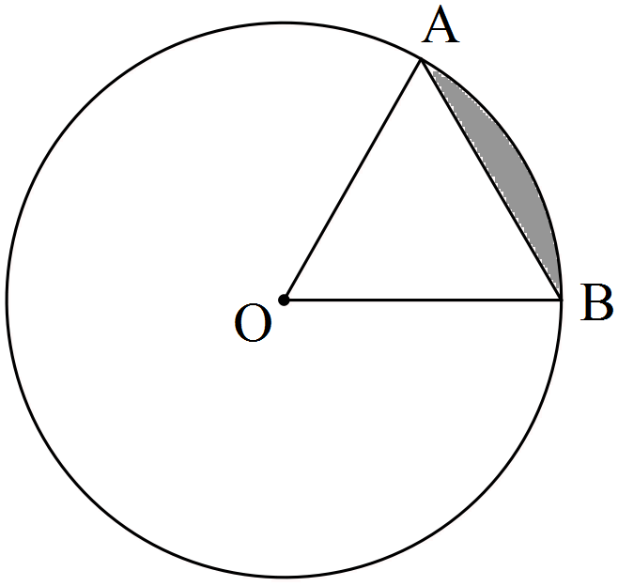
The circle shown with centre O has a radius of 3π cm.
If the size of ∠AOB = 60°, determine the
(a) area of triangle AOB as an exact value in terms of π.

(b) length of the major arc AB accurate to 2 decimal places.

(c) area of the minor sector AOB to the nearest cm².

(d) area of the minor segment (shaded) formed by the chord AB accurate to 1 decimal place.

END OF ASSESSMENT

